班级：智科232 姓名：刘糠杰 学号：202305130222

# Introduction to Stanford University

Stanford University, also known as Leland Stanford University, is a world-renowned private research university located in Palo Alto, south of the San Francisco Bay Area in California, near the famous high-tech park Silicon Valley. Stanford University was founded in 1885 and began to enroll students in 1891. Stanford University and the University of California, Berkeley in the North Bay of San Francisco together constitute the academic center of the western United States, and are responsible for the operation and management of institutions such as the SLAC National Accelerator Laboratory and the Hoover Institution.

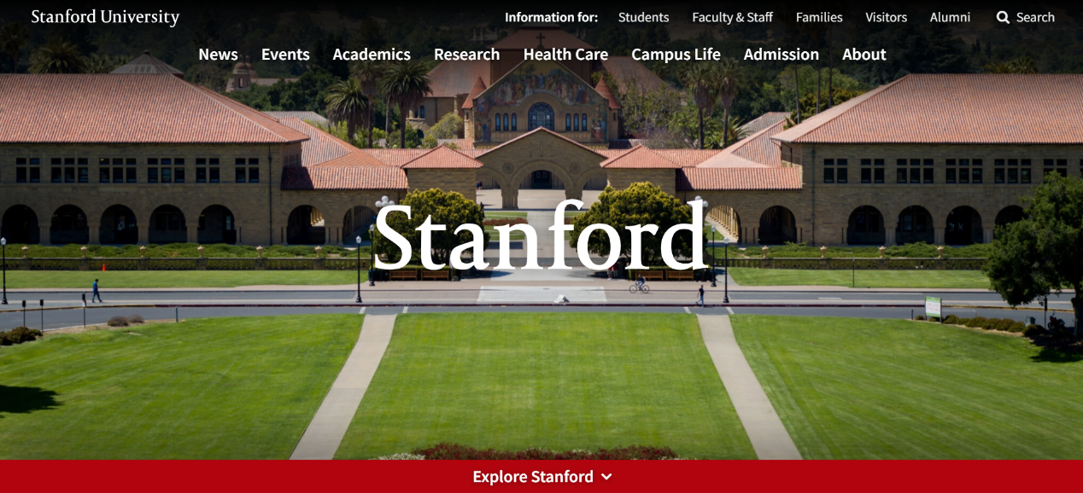

Stanford University Home Page

Stanford University covers an area of 8,180 acres, making it one of the largest schools in the United States, with 18 interdisciplinary research institutes and seven schools on one campus: Graduate Business School; School of Earth, Energy and Environmental Sciences; Graduate School of Education; School of Engineering; School of Humanities and Sciences; School of Law; and School of Medicine.

Stanford University Overview

# Stanford University's achievements

Stanford University has 19 Nobel Prize winners and many famous alumni associated with the school in the fields of art, social sciences, business, politics, humanities, media, sports, and technology. Herbert Hoover, the 31st President of the United States, was a student in Stanford's first class and received a degree in geology in 1895. Alumni also include 17 astronauts, 18 Turing Award winners, and two Fields Medal winners. Stanford University has laid a solid foundation for the formation and rise of Silicon Valley and has trained many leaders of high-tech companies, including the founders of HP, Google, Yahoo, Nike, Logitech, Snapchat, Electronic Arts, Sun Microsystems, NVIDIA, Cisco and LinkedIn. In addition, Stanford's alumni include 30 wealthy entrepreneurs and 17 NASA astronauts, and it is also one of the universities that has trained the most members of the US Congress. Stanford's breakthroughs include the first successful heart-lung transplant, the first invention of the computer mouse, and the development of digital music.

# Stanford University's Mission

The German motto "Die Luft der" is engraved in the official seal of Stanford University, which means "The wind of freedom will always blow." Stanford University was founded nearly 150 years ago with a social mission as its cornerstone. Our mission is to contribute to the world and cultivate students to become people with leadership and integrity; to improve basic knowledge and cultivate creativity; to lead groundbreaking research on effective clinical therapies; to accelerate solutions and expand their impact.

Stanford University logo

Stanford University provides students with opportunities to be exposed to great ideas, to cross conceptual and disciplinary boundaries, and to become global citizens who embrace diversity of thought and experience. We offer students a broad and deep academic program across seven schools and multiple fields —— including arts and humanities, natural and social sciences, engineering, sustainability, medicine, law, education and business. Stanford University's breadth of excellence and innovative culture make it uniquely positioned to attract and retain the best faculty in the world, who provide students with the knowledge and tools to discover and embrace new ideas and prepare for successful careers and lives of service. The need for strong ethical principles to achieve the common good runs through our educational curriculum. Stanford’s outstanding network of alumni and highly engaged alumni community provide students with lifelong access to mentors and classmates who help them forge partnerships with the world beyond campus, again strengthening the collective contributions of our community.

# Introduction to the Department of Psychology at Stanford University

According to the 2024 THE Times World Subject Rankings, Stanford University once again leads the world in the field of psychology, becoming the best psychology school in the United States. Among the first departments established at Stanford University, the Department of Psychology has a long-standing tradition of ground-breaking theoretical research that also has powerful impact in the real world.

社交网络的手机截图上有男人和女人

Stanford University Department of Psychology Home Page

Stanford University's undergraduate psychology program is designed to introduce students to theoretical and empirical research on human behavior. This includes research on aging, achievement, child development, cognitive processes, conflict, culture, decision-making, emotion, group behavior, health, identity, infancy, language, learning and memory, morality, motivation, personality, psychopathology, race, self, social perception, visual perception and other related topics.

# Stanford Prison Experiment

## Experiment Introduction

The Stanford Prison Experiment was a psychological study conducted in 1971 by a research team led by American psychologist Philip Zimbardo in a simulated prison in the basement of the Department of Psychology at Stanford University. The team studied human reactions to imprisonment and the effects of imprisonment on the behavior of authorities and supervisees in prison. The guards and prisoners were all college student volunteers, and the experiment was sponsored by the U.S. Office of Naval Research.

The prisoners and guards quickly adapted to their roles, and the dangers and injuries became increasingly serious. One-third of the guards were considered to show "real" sadistic tendencies, many prisoners were psychologically traumatized, and two had to withdraw from the experiment early. Finally, Zimbardo was warned of the increasing antisocial behavior in this study and terminated the entire experiment early. This change in personality was called the "Lucifer Effect" by him, borrowing the story of Lucifer, God's favorite angel, who later fell into the devil Satan.

## Experimental Procedure

After the experiment began, the research team randomly assigned 24 people to be guards or prisoners in the prison. At that time, some volunteers said that they would rather play the role of prisoners, partly because they could not imagine themselves as guards after graduation. But the volunteers were told that if they were assigned to play the role of prisoners, they might be deprived of their civil rights and receive only minimal food and medical care. Meanwhile, those who were responsible for playing the role of prisoners were told to wait at home on a Sunday, when they were "arrested" by real police and taken to a mock prison in the basement of the psychology department at Stanford University.

The next day, the "prisoners" rioted, tearing off the numbers on their uniforms, refusing to obey orders, and making fun of the guards. Zimbardo asked the guards to take measures to control the situation. The measures they took included forcing the prisoners to do push-ups, stripping them naked, taking away their meals, pillows, blankets and beds, and making them clean toilets with their bare hands. In the end, the situation got completely out of control.

On the fifth day, Zimbardo's colleague Christine (who later became his wife) was invited to the experimental site to observe and question the ethics of the experiment.

## Experimental conclusion

The simulated prison situation can create a new social reality in the minds of prison guards and the people they imprisoned - a real prison.

Personal temperament is not as important as we think. Good and evil are not insurmountable. Environmental pressure can make good people do terrible things. At the beginning of the experiment, there was no difference between the two groups. Less than two weeks later, they had nothing in common. What is particularly remarkable is that the prisoners suspected that the grouping was not random. They thought that the guards were taller than themselves, but in fact, the average height of the two groups was the same.

There is a problem. When Zimbardo said that good people became bad people, those "bad people" did not think they became bad people. They either thought that the victims deserved it, or that they just used evil means to achieve their legitimate goals, and used the rationality of the goals to justify the means they took - the soldiers who tortured prisoners were to obtain the intelligence needed for counter-terrorism, and the terrorists were for national liberation. In the eyes of their colleagues, they were also moral heroes. This is fundamentally a conflict between different good, not a conflict between good and evil, which has gone beyond the scope of psychology.